# https://www.cpp.edu/~jledesma/style.css

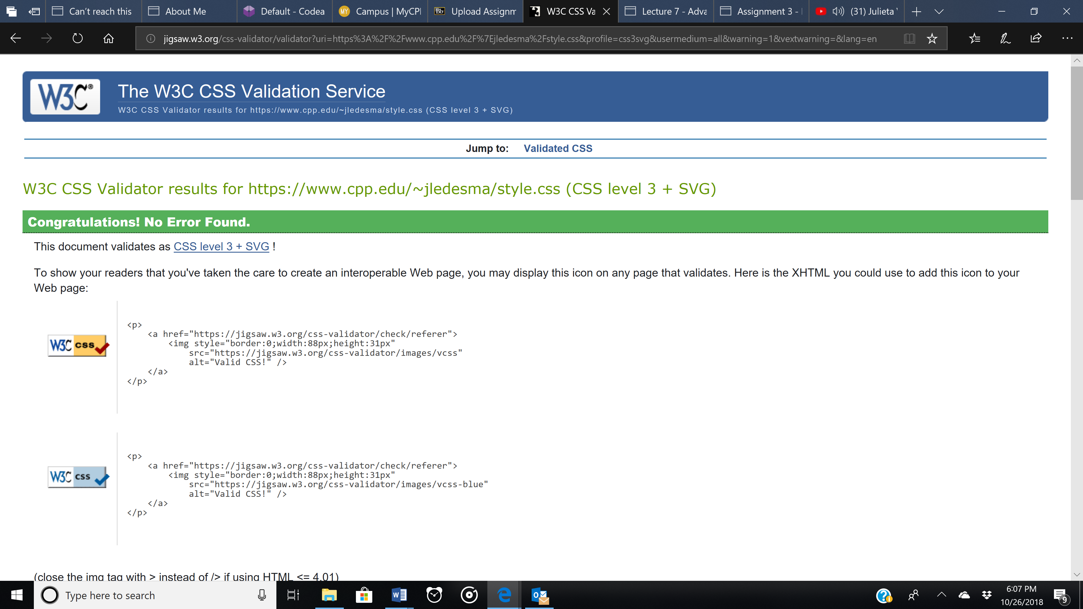

https://www.cpp.edu/~jledesma/adventure.html

